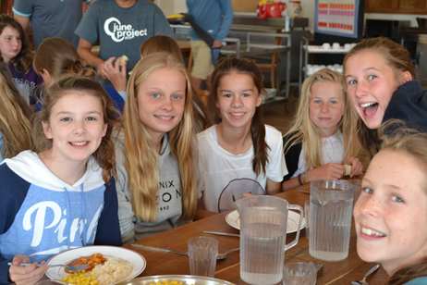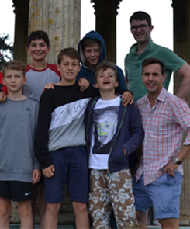
LYMINGTON RUSHMORE HOLIDAYS 2018

Christian activity weeks running every summer for school years 6-8 & 9-13

A Presentation for Parents and Pupils
Thursday 14th September
3.45 – 5.00pm
Ashburton Hall, St Faith’s School
For further details please contact: Mrs Lindsey McCaig (Flora 8L, Alice 6L), Mrs Fiona Saunderson (Caleb 7N),
Miss Jennie Dow, Mr Simon Farewell, Mrs Jane Greaves or Mrs Liz Waldock

