World Food Wednesdays
Each Wednesday we will be offering an authentic dish from a different country at the Theatre Bar
Date | Country |  | Dish
10 January | Oman |  | Machboos
17 January | Chile |  | Empanadas
24 January | Norway | 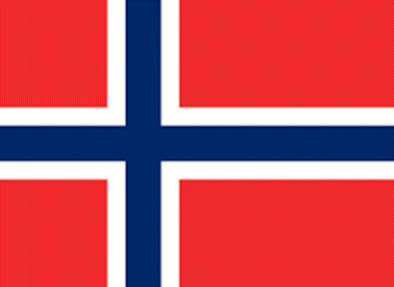 | Pickled Herrings
31 January | Cambodia |  | Kue Teav
7 February | Zimbabwe |  | Sadza Pap with Maize Meal
21 February | Belarus |  | Draniki
28 February | Madagascar |  | Sausage Stroganoff
7 March | Sri Lanka |  | Lamprais
14 March | Serbia |  | Duvec
21 March | Luxembourg |  | Bouchée à la reine

