World Food Wednesdays
Each Wednesday we will be offering an authentic dish from a different country at the Theatre Bar
Date | Country |  | Dish
18 April | Estonia |  | Black Pudding with Sauerkraut
25 April | Bangladesh | 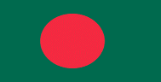 | Chicken Korma
2 May | Malawi |  | Nsima served with “relish” (Meat Stew)
9 May | Bolivia |  | Sandwiches de Chola
16 May | Afghanistan | 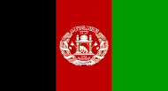 | Manti
23 May | Costa Rica | 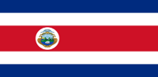 | Chifrijo
6 June | Japan |  | Ramen
13 June | Russia | 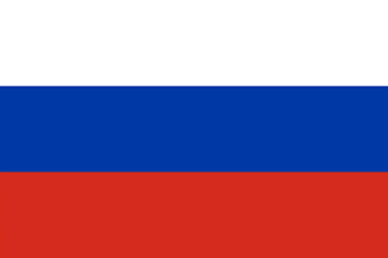 | Russian Salad  (World Cup starts on 14 June)
20 June | Yemen |  | Matfaiya
27 June | Laos |  | Mok Pa
4 July | Spain | 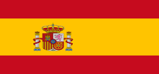 | Cured Spanish Meats

